**INTEL® UNNATI GRAND CHALLENGE SUMMER 2023 PHASE-1**

**PROJECT TITLE : DATA ANALYSIS CHALLENGE WITH UNNATI MOBILITY**

**DATA SET**

**TEAM NAME : CODE_SLAYERS**

**Team Mentor : Dr T V RAJINI KANTH, Professor& Head,**

**Department of CSE-AI&ML**

[**rajinitv@gmail.com**](mailto:rajinitv@gmail.com)**,**

[**rajinikanthtv@sreenidhi.edu.in**](mailto:rajinikanthtv@sreenidhi.edu.in)

**Ph. No: 9849414375**

**Team Members : T. V. S. Aneesh** Roll no: 20311A0503 CSE Team lead

**G Dheemanth Reddy** Roll no: 20311A0533 CSE Team member

**T Bharath Kumar** Roll no: 20311A0506 CSE Team member

**Institute Name : Sreenidhi Institute of Science and Technology**

**Yamnam Pet, Ghatkesar**

**Hyderabad - 501301**

**Date of submission : 10 -09- 2023**

**ABSTRACT:**

The surge in mobility data availability has unlocked opportunities in understanding human behaviour, optimizing transportation systems, and enhancing urban planning, with a focus on accident prevention. This abstract outlines an extensive data analysis project on a diverse mobility dataset. Its goal is to reveal insights, patterns, and trends and alert drivers. The dataset includes GPS tracking and alarm data, and the workflow covers data cleaning, pre-processing, exploratory analysis, classification, clustering, advanced techniques, and spatial mapping. Key findings include congestion hotspot identification, analysing driver behaviour, predictive traffic models, and anomaly detection for crisis management. These insights benefit urban planners, transportation firms, and policymakers, emphasizing data-driven decision-making for safer mobility, accident avoidance through alert systems and urban planning.

***Keywords: Mobility Data set, types of alarms, GPS tracking, clustering techniques, traffic congestions, accidents.***

**INTRODUCTION**

In our increasingly interconnected world, the analysis of mobility data has emerged as a critical endeavour with profound implications for urban planning, transportation management, the overall well-being of society and accident avoidance. The ubiquity of smartphones, GPS devices, and Internet of Things (IoT) sensors has given rise to vast repositories of data that capture the movements of people, vehicles, and goods. This rich and diverse dataset, often referred to as mobility data, presents an unprecedented opportunity to gain insights into how individuals and communities move within and between urban areas in order to reduce or avoidance of accidents. This analysis project sets out to explore the wealth of information contained within mobility datasets. This analysis makes the project underscores the increasing importance of data-driven approaches in shaping the future of mobility and accidents avoidance through alarm systems.

**MOTIVATION**

Motivation factors for analysing mobility data for road safety are 1) Distracted driving is a leading cause of accidents. Mobility data can be analysed to detect signs of driver distraction. Alarm systems can then intervene to refocus the driver's attention on the road. 2) Long hours of driving and fatigue can impair a driver's reaction time and decision-making. Mobility data can help identify signs of fatigue, such as irregular driving patterns or extended periods without rest breaks. Alarm systems can provide timely alerts to prevent accidents due to driver exhaustion.3) In summary, the motivation for analysing mobility data to develop alarm systems for drivers is rooted in the critical need to enhance driver safety, reduce accidents, and improve road conditions. These systems have the potential to save lives, reduce injuries, and create safer roadways for all users.

**DATA SOURCES:**

Utilized the LocationIQ website's API capabilities to access and extract pertinent data, encompassing tasks such as plotting geographical coordinates on maps, conducting searches for nearby hospitals, geocoding, and reverse geocoding operations.

**ARCHITECTURE:**

Input Data (Mobility Data Set)

Data pre-processing

Data Visualisation

Multi linear Regression

Clustering &

Mapping

**MOBILITY DATA SET RESULTS, ANALYSIS AND CONCLUSIONS:**

Filtered PCW alerts with speeds exceeding 40 km/h and FCW alerts surpassing 50 km/h. DBSCAN clustering algorithm was employed to identify safety-centric spatial clusters, extracting cluster centroids as focal points representing areas with dense alerts and high-speed vehicle occurrences. These centroids were visually mapped, amalgamating insights from both PCW and FCW analyses to guide precise safety strategies.

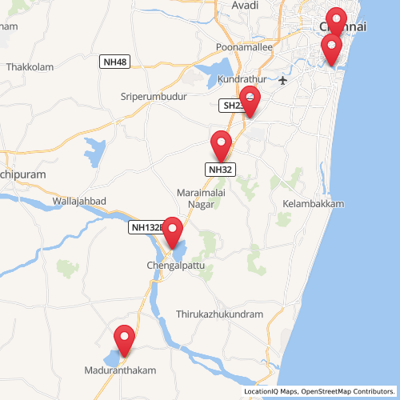 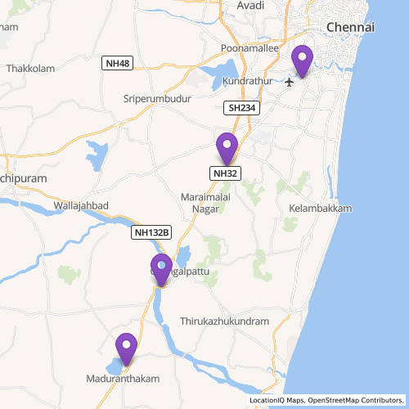

**Fig 1. Areas unsafe for pedestrains Fig 2. FCW alert hotspots**

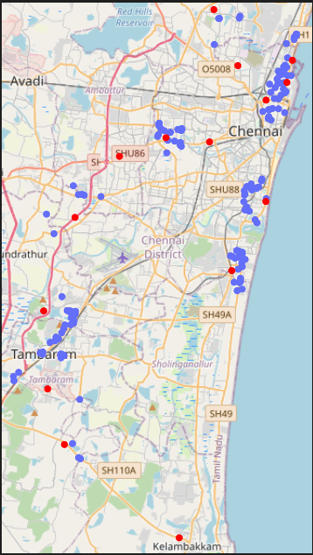Red marks -> blackspots

Blue marks -> hospitals

This map Fig.3 shows marked accident-prone areas, emphasizing high-frequency accident zones. Notably, the Kelambakkam accident hotspot lacked hospitals within a 3-kilometer radius, demanding the urgent establishment of healthcare facilities for enhanced road safety and prompt medical care in accidents.

**Fig 3. Blackspots and nearby hospitals**

An unusual number of alerts have been recorded in the first 15 days of August 2022 (depicted in the red box inFig-4). The cause for this is believed to be because of the festival ‘Vinayaka Chaturthi’.Extra measures should be taken by the government during this festival.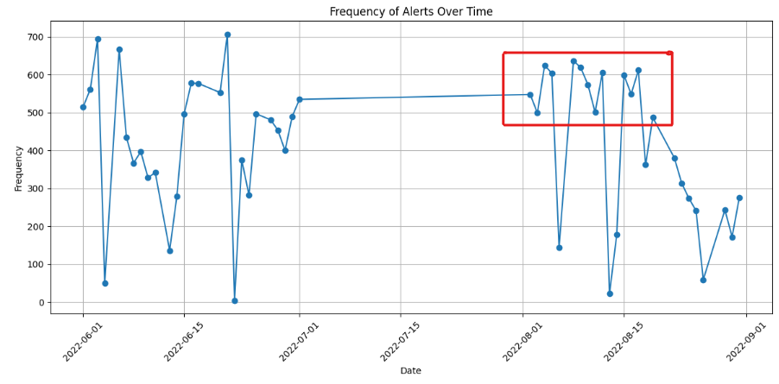

**Fig-4: Frequency of Alerts on different dates**

Another trend discovered is the number of ldw and hmw alerts that were recorded starting from 1:00 am to 3:00 am in early hours of everyday were unusually high. This can be attributed with the driver’s drowsiness. So instead of just giving a visual alert, it would be better if an audio alert is given as it would increase the driver’s attention towards the road. (See Fig-5,Fig-6)

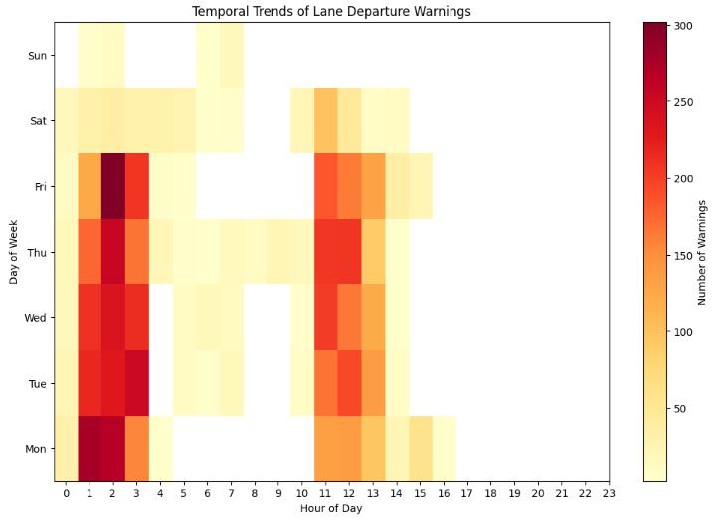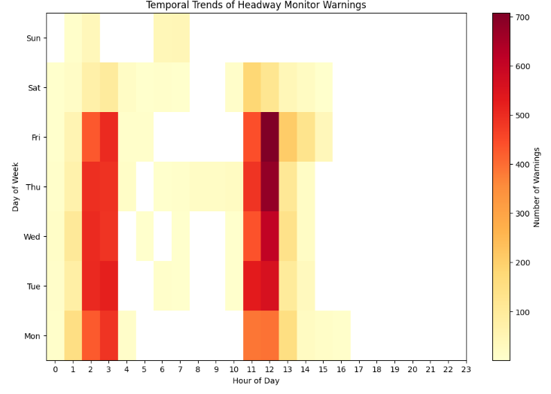

**Fig-5. Temporal trends of ldw alerts Fig-6.Temporal trends of hmw alerts.**

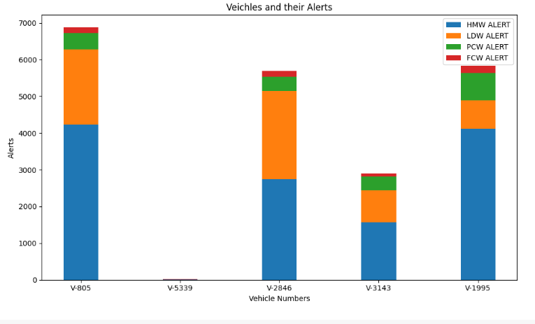In the span of 53 days, 6431 ldw alerts were recorded which is alarming and actions need to be taken to make drivers follow lane discipline**.**

**Fig-7 Vehicles and their alerts**

The Table-1 showed the results of Multi linear regression (MLR) predicted values of Alerts

|  |  |  |  |
| --- | --- | --- | --- |
| **Table-1: Multi Linear Regression prediction results on Alert Prediction** | | | |
| Index of Record | Alert | Predicted value of alert without Date attribute included in independent variable (accuracy 80%) | Predicted value of alert with Date attribute included in independent variable  (accuracy 80%) |
| 15132 | cas_ldw | cas_ldw | cas_ldw |
| 4704 | cas_hmw | cas_ldw | cas_ldw |
| 7273 | cas_hmw | cas_hmw | cas_hmw |
| 18244 | cas_hmw | cas_hmw | cas_hmw |
| 12175 | cas_ldw | cas_ldw | cas_ldw |

**CONCLUSIONS:**

DBSCAN clustering algorithm has shown safety-centric spatial clusters, representing areas with dense alerts and high-speed vehicle occurrences. Multi linear regression has predicted the alerts with 80% accuracy. In the span of 53 days, 6431 ldw alerts were recorded which is alarming and actions need to be taken to make drivers follow lane discipline. The number of ldw and hmw alerts that were recorded starting from 1:00 am to 3:00 am in early hours of everyday were unusually high. The high-frequency accident zones is identified as Kelambakkam area which has no hospitals within a 3-kilometer radius. These are the important conclusion observed from the Mobility Data analysis project.

**FUTURE SCOPE:**

Future road safety data analysis includes: 1) Enhanced predictive models.2)Real-time monitoring with IoT.3)Targeted driver behaviour interventions.4)Smart infrastructure implementation.5) Optimized emergency response.6)Improved regulatory compliance.7)Integration with autonomous vehicles.

**REFERENCES**

[1]. [Advanced_Driver-Assistance_Systems_A_Path_Toward_Autonomous_Vehicles](https://www.researchgate.net/publication/327253343_Advanced_Driver-Assistance_Systems_A_Path_Toward_Autonomous_Vehicles)

[2]. [LocationIQ](https://my.locationiq.com/) 3].[NumPy](https://numpy.org/) [4]. [Matplotlib](https://matplotlib.org/) [5]. [TamilNadu Road Safety](https://www.tnhighways.tn.gov.in/en/roadsafety) [6]. [Review_of_advanced_driver_assistance_systems_ADAS](https://www.researchgate.net/publication/321364551_Review_of_advanced_driver_assistance_systems_ADAS)

**SOURCE CODE AND CONFIGURATION FILES:** Github repository for the project is attacted. [GithubLink](https://github.com/Bharath26214/IntelChallenge) <https://github.com/Bharath26214/IntelChallenge>,

Clustering_insights.ipynb, Data_visualization.ipynb.